

**Contents**

1. Student Council Members………………………………………………………………………2

2. Role and Responsibilities………………………………………………………………………..2

3. Interest Group Councillor Communication Structure…………………………..…………3

4. List of Interest Group Councillor Roles…………………………………………………………3

5. Interest Group Councillor Chairperson Role…………………………………………………3

6. Meetings Schedule…………………………………...………………………………………….5

7. Skills & Personal Development MCQ………………………………………………………….6

8. Student Council Structure……………………………………………...……………………….6

9. Student Council Bye Law……………………………………………………….………………6

10. Student Officer Team……………………………………………………………..……………7

11. President’s Volunteer Award………………………………………………..………………..8

12. Leadership and Representation Office (LRO)……………………………………………10

**Interest Group Councillor**

Congratulations on becoming a member of Student Council. As an elected Interest Group Councillor, you play an essential role in the work of Student Council for this academic year. Student Council is about good communication and teamwork.

There are 56 Student Council members: 12 Executive Officers; 26 Department Representatives; and 18 Interest Group Councillors. Each Department in the university has one Representative.

A Student Representative ensures that the student voice is heard by using democratic forums to gather feedback from the student body, and then in turn discuss this feedback with University staff and student committees.

**Your Role & Responsibilities**

You have a hugely important role on Council.

* You are the student voice within UL for your area.
* You are a member of an interest group which has a chairperson.
* The chairperson is a member of both Student Executive and Student Council.
* The chairperson will contact you to organise an introductory meeting.
* The information will be shared by the chairperson in a report to Student Council.
* You will work closely with the group to promote relevant initiatives both within and outside the university.
* You need to attend all Council meetings.
* You must send apologies to the Chair of Council & copy Siobhán Wilmott, Student Representation Co-ordinator if you are unable to attend meetings.
* Your role on Council is to get feedback from the wider student body about your area and report this information back to the interest group and chairperson.
* Seek additional support from your chairperson.
* It is not your responsibility to support students with personal issues. Encourage students to book a call with our Student Information and Support Coordinators.
  + Book in with [Nicole](https://calendly.com/nicole-m-ryan) or [Shane](https://calendly.com/shane-laffan). You can learn more about their services [here.](https://leadersforlife.ie/courses/understanding-your-role-class-reps/lessons/help-support-establishing-boundaries/topic/help-and-support/)
* As a member of Student Council you hold your Executive to account through participation on Council. This is furthered by having an Executive Oversight Committee (made up of Student Council members).
* Please note: every Council member can volunteer to sit on the Executive Oversight Committee. See link for more information <https://www.ulstudentlife.ie/get-involved/student-life-executive/>

**Important Dates**

Part of your key responsibilities as an Interest Group Councillor is to attend forums and Council meetings. These spaces are designed to be interactive, creative listening spaces where you can discuss issues faced by students and interact with UL staff and supports services. Have your voice heard and make sure to join us at meetings and forums!

**UL Student Life Student Council Meetings | 2023/24**

|  |  |
| --- | --- |
| Semester One | |
| Tuesday of Week 4 | **Tuesday of Week 6** |
| Tuesday October 3rd 2023, 6 PM | Tuesday October 17th 2023, 6 PM |
| Tuesday of Week 8 | **Tuesday of Week 10** |
| Tuesday October 31st 2023, 6 PM | Tuesday November 14th 2023, 6 PM |
| Tuesday of Week 12 |  |
| Tuesday November 28th 2023, 6 PM |  |

**Student Forums | 2023/24**

|  |  |
| --- | --- |
| Semester 1 | Wednesday, October 25th 2023, 6 PM |
| Semester 2 | Wednesday, February 28th 2024, 6 PM |

# A group of colorful posters Description automatically generatedLeaders for Life

Leaders for life is unlike any programme currently being run for student representatives in Irish colleges. Our aim is to champion and empower those brave students who want to step out of the crowd and put themselves forward as student representatives within the college community.

We want to provide them with practical skills that will enable them to understand their role and be able to conduct their role as a representative effectively. But we also want to support and inspire them to go beyond the role and develop their inner leader.

Log onto [**Leaders for Life**](https://leadersforlife.ie/registration/), a Student Leadership Programme, designed specifically for UL student leaders, and complete a **compulsory 60-minute induction,** entitled *‘Understanding Your Role*’. You also have access to 2 additional Leadership Training Modules that when completed will award you with a gold certification. Follow the link above to get started and use your interest group councilor code **interestleader23.**

**Interest Group Councillor Communication Structure**

|  |  |  |
| --- | --- | --- |
| Student Officer | Chairperson | Interest Group Councillor Grouping |
| Welfare ↔ | Student Events ↔ | Sports Councillor; Activities Councillor; and Entertainments Councillor |
| Communities ↔ | Equality & Diversity ↔ | Equal Opportunities Councillor; Mature Student Councillor; Disabilities Councillor; LGBTQI Councillor; Home International Councillor; Visiting International Councillor; Sanctuary Representative; and Parent Representative. |
| Welfare ↔ | UL Experience ↔ | Volunteering Councillor; Campus Facilities Councillor; Student Services Councillor; Community Councillor; Experience Councillor; and Cooperative Education Councillor. |

**List of Interest Group Councillors**

**Student Affairs**

Student Affairs councillor would engage with the Student Affairs division of the University and get feedback from them in terms of any trends or issues that are arising in the various services. For example, this councillor would feedback information from the disabilities service to council to open discussion around supports needed, campaigns etc.

**Sports**

Sports councillor would be in contact with UL Sport and the major sporting clubs in UL. Their role would be to communicate with council around areas that need to be addressed in terms of sports offerings, facilities and sports promotion.

**Activities**

Activities councillor would liaise with the student engagement co-ordinator around the kind of events students want to see on campus and then bring this information to council. They would also bring any relevant notices to council from societies on campus that we council could help promote to students etc.

**First Year**

First Year councillor would engage with the First Year Support Co-Ordinator on a regular basis to discuss any common themes or issues arising for first year students. These issues or themes could then be brought to council where they can be discussed and solutions could be found.

**Student Services**

Student Services councillor would work in a similar vein to the student Affairs councillor in engaging with the various support services around campus, collecting feedback and data that could then inform policy/campaigns going forward.

**Co-Op**

Co-Op councillor would liaise with the Co-Op Office and get a sense of what supports student need while on co-op and before that when applying for placements. By working with the co-op office directly, council can be better informed about policy changes that could support students in the co-op process.

**Campus Facilities**

Campus Facilities councillor would liaise with the relevant groups around UL in terms of the facilities offered to students including educational, social and sporting. Where issues or concerns are identified around the facilities on campus, council can discuss ways in which work can be done to rectify them.

**Equality & Diversity Councillor**

Equality & Diversity Councillor councillor would liaise with the various student support areas of UL e.g. Access / Disability etc. They would engage with UL to ensure that the university adheres to the Equality and Diversity policy. Also UL Global and International Society to seek opportunities to engage and support diverse student groups on campus.

**Disabilities Councillor**

Disabilities councillor would liaise with the disability service to get a sense of the issues faced by students with disabilities. Through regular engagement with the service, opportunities to meet and engage with students to get feedback . When feedback is received and issues are identified Council can discuss ways in which work can be done to rectify them.

**Home International Councillor**

Home International councillor would liaise with UL Global and International Society to seek opportunities to engage and international student groups on campus. Engage with the student engagement co-ordinator around suggestions of types of entertainment and activities students want to experience and then bring this information to council. Also explore opportunities to engage with international student reps on Student Executive and Student Council to ensure they are part of the UL community.

**Visiting International Councillor**

Visiting International councillor would liaise with UL Global and International Society to seek opportunities to engage and support diverse student groups on campus. They would also seek ideas from student Council and highlight issues.

**Mature Student Councillor**

Mature Student councillor would liaise with the Mature Student Office to get a sense of the issues faced by mature students. Through regular engagement with the service, opportunities to meet and engage with students to get feedback. When feedback is received, and issues are identified Council can discuss ways in which work can be done to rectify them. E.g. C&S, Activities, Entertainments etc

**LGBTQI Councillor**

LGBTQI councillor would liaise with the LGBTQ+ support Groups and Societies on campus to then to be the voice of the student group in order to highlight issues with Council can discuss new ideas on how to support the students.

**Entertainments Councillor**

Entertainments councillor would liaise with the student engagement co-ordinator around suggestions of types of entertainment students want to experience and then bring this information to council. They would also liaise with class reps to seek ideas on what are popular trends for entertainment.

**Volunteering Councillor**

Volunteering councillor would look at the promotion of volunteering opportunities on campus. They would liaise with the PVA and local charity organisation to recruit students to volunteer for worthy causes. They would also seek advice and ideas from Council on volunteering on campus and the local communities e.g. Access Campus.

**Community Councillor**

Community councillor would liaise with UL Student Life and students to positive engagement between students and the local community. They would promote the MnM initiative to the student body. They would also seek ideas from student Council to promote community engagement.

**Student Parent Rep**

Student Parent would liaise with the university to represent student parents and highlight issues faced by these students while attending UL. They would liaise with Access / Mature offices, as well as UL Creche. to positive engagement between students and the local community.. They would also seek ideas from student Council to promote community engagement and highlight issues.

**Sanctuary Rep**

Sanctuary Rep would liaise with the university to represent sanctuary students and highlight issues faced by these students while attending UL. They would explore ways to engage with students to make their experience in UL positive. They would also seek ideas from student Council and highlight issues.

**Interest Group Chairperson Role**

There are 3 Chairpersons, who each chair a separate Interest Group. See below.

**Student Events Chair**

The role of Student Events Chair include:

* Representing the recreation agenda
* Seeking the views of students relating to their experience of recreational activity within the Union and University
* Keeping informed of recreation developments internally, nationally and internationally
* Establishing and communicating the views of students to the relevant stakeholders within the Union and University
* Arranging monthly meetings with the Councillors in your interest group
* Acting as chair at monthly group meetings
* Addressing issues that arise with the Head of relevant services such the Director of Sport and Recreation and any department heads for whom there is no corresponding Councillor as required or at least twice per semester
* Maintaining a close working relationship with the other Council Chairs
* Coordinating events aimed at promoting recreational activity with the assistance of the Union’s Events and Promotion Manager
* Liaising with the Chair of Council to ensure information passes to all students
* Promoting Union campaigns and engagement amongst students
* Maintaining a log of all issues arising relating to recreation, their status and date of resolution to be sent to the President in weeks 4, 8 and 12 of each semester, or more frequently as necessary
* Attending all scheduled Council Meetings, Student Forum meetings and relevant Council sub-committee meetings
* Working as part of the Student Life team to ensure the effective democracy and engagement.

**Equality and Diversity Chair**

The role of Equality and Diversity Chair include:

* Representing the equal opportunities agenda
* Seeking the views of students relating to their experience of equality of opportunity within the Union and University
* Keeping yourself informed of equal opportunities developments internally, nationally and internationally
* Establishing and communicating the views of students to the relevant stakeholders within the Union and University
* Arranging monthly meetings with the Councillors in your interest group
* Acting as chair at fortnightly monthly group meetings
* Addressing issues that arise with the Head of relevant services such the Director of Student Affairs and any department heads for whom there is no corresponding Councillor as required or at least twice per semester
* Maintaining a close working relationship with the other Council Chairs
* Coordinating events aimed at promoting Equal Opportunities with the assistance of the Union’s Events and Promotion Manager
* Liaising with the Chair of Council to ensure information passes to all students
* Promoting Union campaigns and engagement amongst students
* Maintaining a log of all issues arising relating to equal opportunities, their status and date of resolution to be sent to the DP Welfare in weeks 4, 8 and 12 of each semester, or more frequently as necessary
* Attending all scheduled Council Meetings, Student Forum Meetings and relevant Council sub-committee meetings
* Working as part of the Student Life team to ensure the effective democracy and engagement

**UL Experience Chair**

The role of UL Experience Chair include:

* Representing the UL experience agenda
* Seeking the views of students relating to their overall experience of the Union and University
* Keeping yourself informed of student experience developments internally, nationally and internationally
* Establishing and communicating the views of students to the relevant stakeholders within the Union and University
* Arranging monthly meetings with the Councillors in your interest group
* Acting as chair at monthly group meetings
* Addressing issues that arise with the Head of relevant services such the Director of Student Affairs and any department heads for whom there is no corresponding Councillor as required or at least twice per semester
* Maintaining a close working relationship with the other Council Chairs
* Coordinating events aimed at developing an insight into what students’ ideal UL experience would be with the assistance of the Union’s Events and Promotion Manager
* Liaising with the Chair of Council to ensure information passes to all students
* Promoting Union campaigns and engagement amongst students
* Maintaining a log of all issues arising relating to the UL experience, their status and date of resolution to be sent to the relevant Sabbatical Officer in weeks 4, 8 and 12 of each semester, or more frequently as necessary
* Attending all scheduled Council Meetings, Student Forum Meetings and relevant Council sub-committee meetings
* Working as part of the Student Life team to ensure the effective democracy and engagement

**Student Council Meetings Schedule**

|  |  |
| --- | --- |
| Semester One | |
| Tuesday of Week 4 | **Tuesday of Week 6** |
| Tuesday October 3rd 2023, 6 PM | Tuesday October 17th 2023, 6 PM |
| Tuesday of Week 8 | **Tuesday of Week 10** |
| Tuesday October 31st 2023, 6 PM | Tuesday November 14th 2023, 6 PM |
| Tuesday of Week 12 |  |
| Tuesday November 28th 2023, 6 PM |  |

|  |  |
| --- | --- |
| Semester Two | |
| Tuesday of Week 3 | **Tuesday of Week 5** |
| Tuesday, February 13th 2024, 6PM | Tuesday February 27th 2024, 6 PM |
| Tuesday of Week 7 | **Tuesday of Week 9** |
| Tuesday March 12th 2024, 6 PM | Tuesday March 26th 2024, 6 PM |
| Tuesday of Week 11 |  |
| Tuesday, April 9th 2024, 6 PM |  |

**Skills & personal development**

Please select the skills from the list below that a Student Council member may learn and develop;

|  |  |  |  |
| --- | --- | --- | --- |
| Option A | Option B | Option C | Option D |
| ○ Leadership  ○ Communication  ○ Negotiation | ○ CV Building | ○ Listening  ○ Teamwork | ○ All Options |

**Council Structure**

Please familiarise yourself with the Student Council role chart below to see your role within the Student Council structure.

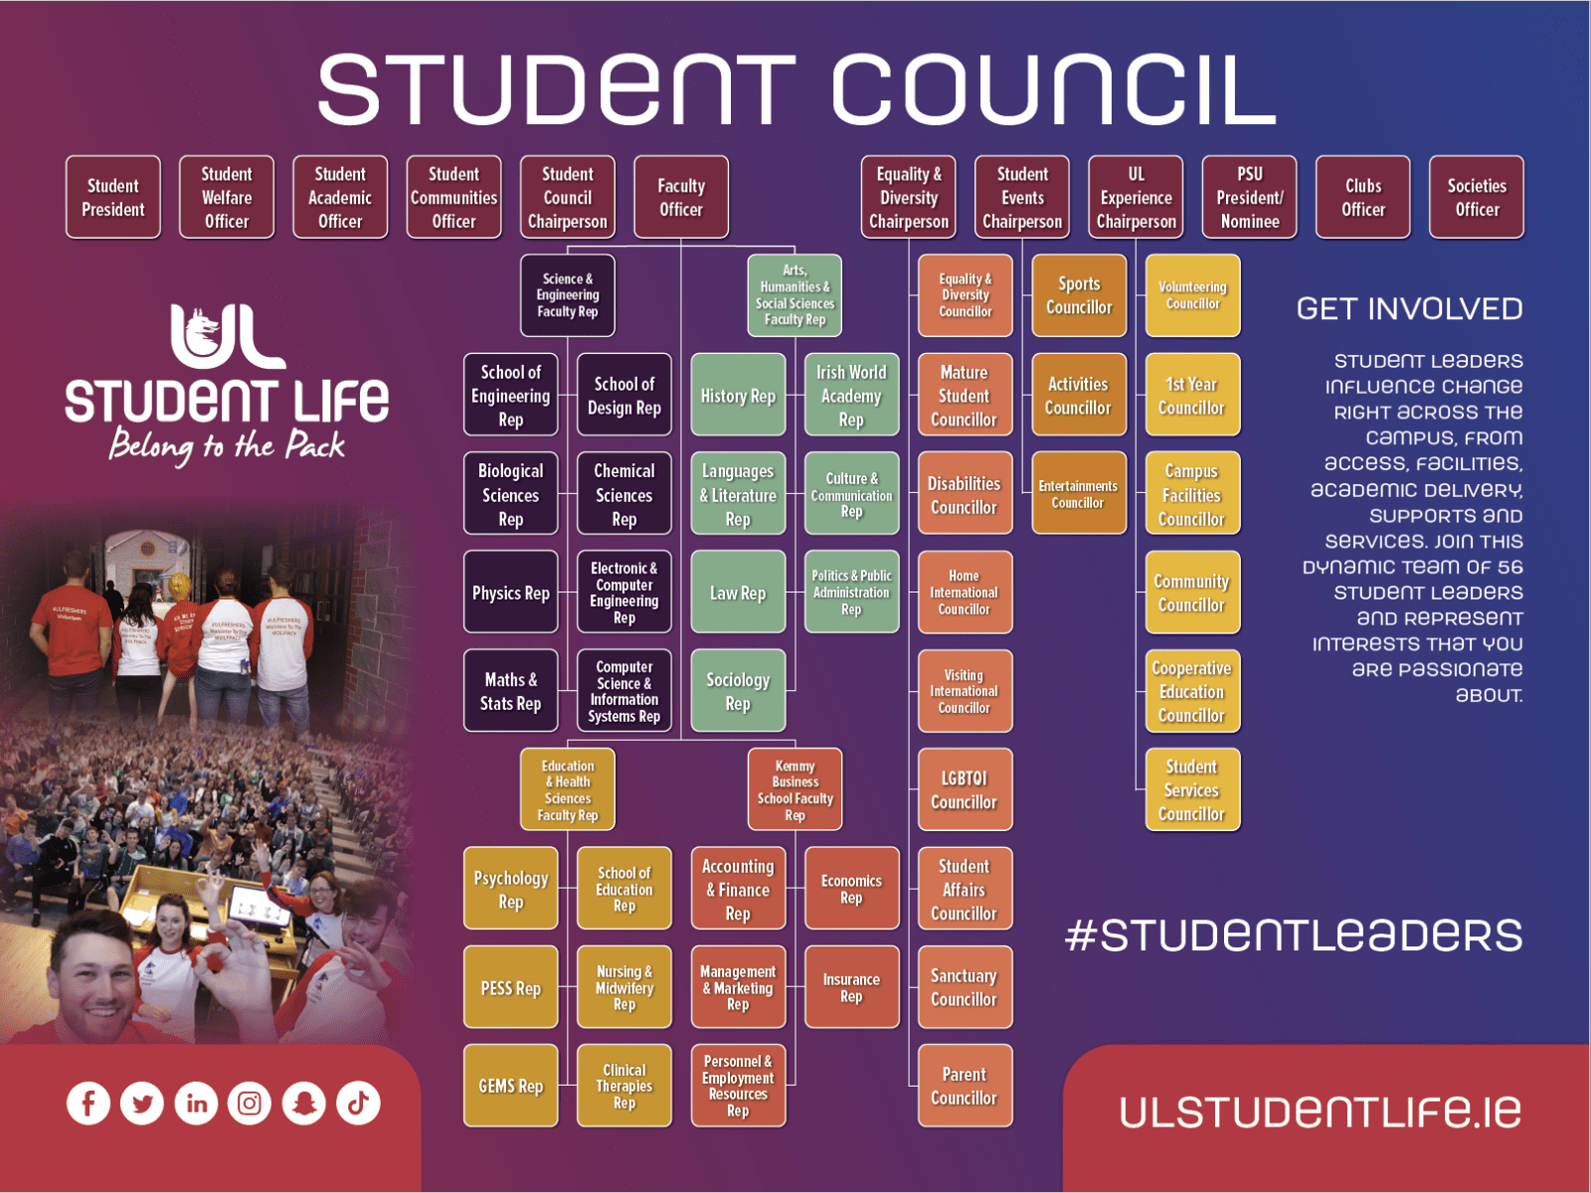

**Student Council Bye Law**

For additional information about your role on Student Council, please familiarise yourself with the Student Council Bye-Law here <https://www.ulstudentlife.ie/about/su-governance/> This is an important document as it explains the purpose and function of Student Council. You can also email [jasmine.ryan@ul.ie](mailto:jasmine.ryan@ul.ie) for further questions.

**Meet Your Student Officer Team**

**Student President Vice President Academic Officer**

Ronan Cahill Ronan Mannix

Email: [studentpresident@ul.ie](mailto:studentpresident@ul.ie) Email: [studentacademic@ul.ie](mailto:studentacademic@ul.ie)

**Deputy President Welfare Officer Vice President Communities Officer**

Emily Rosenkranz Katie Martin

Email: [studentwelfare@ul.ie](mailto:studentwelfare@ul.ie) Email: [studentcommunities@ul.ie](mailto:studentcommunities@ul.ie)

Presidents Volunteer Award - PVA

As a member of Student Council, you can apply for the Presidents Volunteer Award.

The award recognises the work of student volunteers within the University of Limerick and beyond. To apply for the Student Council Opportunity follow the steps below.

Step 1

Log onto <https://www.studentvolunteer.ie/sign-up> to create an account.



Step 2

Select UL Student Council in ‘Opportunities’ search

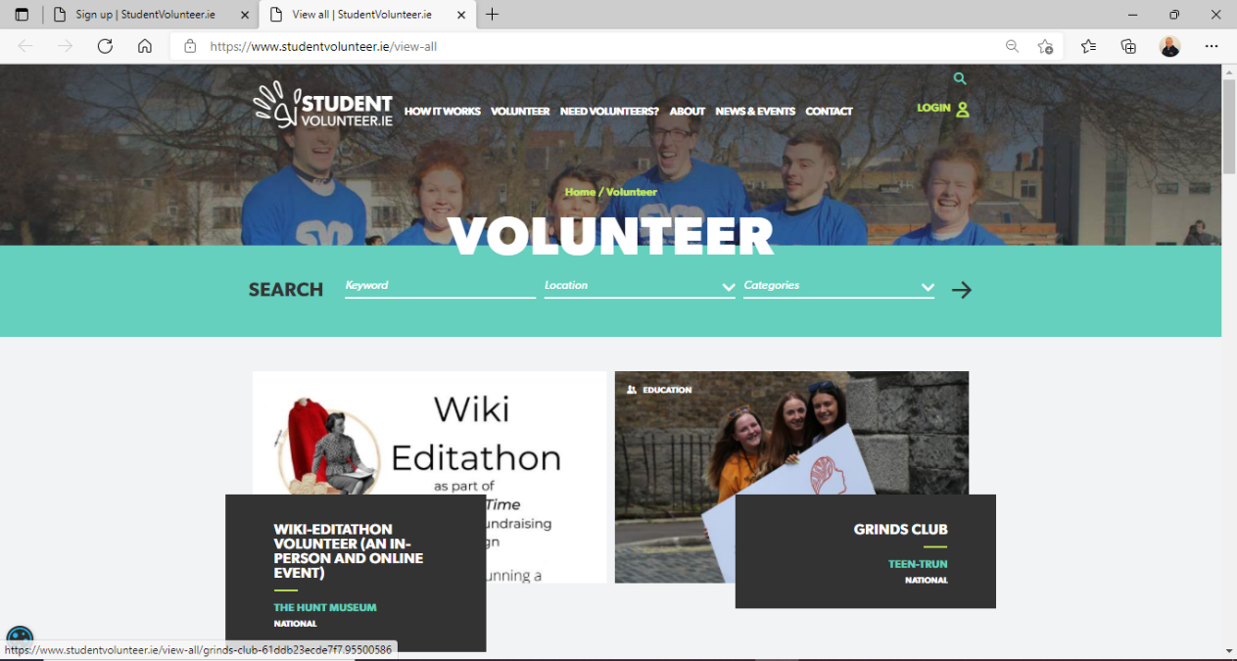

Step 3

* Log all your hours on studentvolunteer.ie.
* Make sure all hours have been approved by your volunteer supervisor.
* Complete reflective portfolio.
* **Students must achieve a minimum of 20 hours to apply for a PVA.**

**Types of Awards:**

**Gold -**minimum of 60 volunteer hours

**Silver -**minimum of 40 volunteer hours

**Bronze -**minimum of 20 volunteer hours

* Any questions - contact the PVA Team at [pva@ul.ie](mailto:pva@ul.ie)

# Meet the Leadership & Representation Team



**Gillian O’ Gorman  
Head of Student Leadership & Advocacy**

In my role as Head of Leadership & Advocacy, I oversee both the Leadership & Student Representation office, and the Student Information and Support Service. I work with a team of four staff, along with the four Student Officers, to ensure that the student voice is heard and fed back through university committees. This is done by providing our student reps with a comprehensive induction and leadership training through our Leaders for Life training program.

I am also responsible for ensuring that UL Student Life delivers a best-in-class support service through both student information and support co-ordinators. Trends in supports are examined monthly and feed into the overall delivery of service and the strategic direction of the organisation. As part of the Senior Management team, I am responsible for the development of organisational policies and good governance at all times.

Email: [gillian.ogorman@ul.ie](mailto:gillian.ogorman@ul.ie)



**Siobhán Willmott   
Student Representation Coordinator**

It is my job to recruit all student representatives and oversee the elections, as well as providing support and training opportunities to over 300 student reps each year. I love my job because I’m passionate about student voice, leadership, and representation. I would love to see a diverse and inclusive range of student reps so that all UL students feel their views are represented at a leadership level. If you share my passion and want to get involved, then nominate yourself to become one of the leaders of our pack. Don’t worry, we will provide Leaders for Life training to help you be a student rep.

Still uncertain of what’s involved or how to get involved? Contact me. We want to support you, so please get in touch. Send me an email or book an appointment using the links below.

Email [siobhan.wilmott@ul.ie](mailto:siobhan.wilmott@ul.ie)

**Jasmine Ryan**

**Leadership & Representation Administrator**

Jasmine is the Leadership & Representation Administrator and works alongside Gillian & Siobhán in the Student Leadership & Representation Office. Her primary role is to support the Leadership & Representation office in the recruitment, engagement, and training of all student representatives. She takes Student Council Minutes as well as circulating all documents before meetings. Jasmine is a member of the Class Rep Forum Planning team. She also processes the online Class Rep & Student Council nominations. Jasmine approves all of the Representation Opportunities for Student Reps through the Presidents Volunteer Award. She supports Siobhán in the recruitment of Student Reps & NStEP Training. She is the first point of call for all student representation queries that come to the Leadership & Representation Office.

Email: [jasmine.ryan@ul.ie](mailto:jasmine.ryan@ul.ie)