**Contents**

Student Council Members………………………………...………………..……………..………2

Role and Responsibilities………………………………………………………………….………..3

Meetings Schedule………………………………………,,…………………………….………….3

Skills & Personal Development MCQ…………………………………………………………….3

Student Council Structure………………………………………………………..………………..4

Student Council Bye Law……………………………………………….………………………….4

Student Officer Team……………………………………………………………………………….5

President’s Volunteer Award……………………………………...………………………………6

Leadership and Representation Office (LRO)……………….…………………………………8

Appendix……………………………………………………………………………………………10

**Department Representative**

Congratulations on becoming a member of Student Council. As an elected Department Rep you play an essential role in the work of Student Council for this academic year. Student Council is about good communication and teamwork.

There are 56 Student Council members: 12 Executive Officers; 26 Department Representatives; and 18 Interest Group Councillors. Each Department in the university has one Representative.

A Student Representative ensures that the student voice is heard by using democratic forums to gather feedback from the student body, and then in turn discuss this feedback with University staff and student committees.

**Your Role & Responsibilities**

Department Representatives act as facilitators between the Class Representatives and the Module Leaders. Their responsibilities include creating their own record of the conversation and resolutions/ differences that they note. The Department Rep should consult the report received to them by the Class Representative if they are not already a registered Class Representative in that module. The Department Rep must include all Class Representative in any correspondence and request a meeting with everyone present. If you are unsure about all the Class Representatives involved, please email [jasmine.ryan@ul.ie](mailto:jasmine.ryan@ul.ie) for the updated list.

You have a hugely important role on Council.

* You should introduce yourself to your Course Leader as soon as you are elected and request a virtual meeting. (See Appendix One for sample email to Course Leader).
* You need to attend all Council meetings.
* You must send apologies to the Chair of Council & copy the Student Representation Co-ordinator if you are unable to attend meetings.
* Your role on Council is to bring forward department issues & interests to Council.
* Your Responsibility is to bring updates from Student Council to students in your department.
* Liaising with class reps regularly is very important as issues may arise for students on academic issues (email [jasmine.ryan@ul.ie](mailto:jasmine.ryan@ul.ie) to request class rep list. (See Appendix Two for sample email to Class Reps).
* Seek additional support from Faculty Rep / Faculty Officer & Academic Officer.
* It is not your responsibility to support students with personal issues. Encourage students to book a call with our Student Information and Support Coordinators.
  + Book in with [Nicole](https://calendly.com/nicole-m-ryan) or [Shane](https://calendly.com/shane-laffan). You can learn more about their services [here.](https://leadersforlife.ie/courses/understanding-your-role-class-reps/lessons/help-support-establishing-boundaries/topic/help-and-support/)
* You are encouraged to attend NStEP training as it will give you important skills to help you fulfil your role. Log onto the link here for more information <https://studentengagement.ie/student-training/>
* As a member of Student Council you hold your Executive to account through participation on Council. This is furthered by having an Executive Oversight Committee (made up of Student Council members).
* Please note: every Council member can volunteer to sit on the Executive Oversight Committee. See link for more information <https://www.ulstudentlife.ie/get-involved/student-life-executive/>

**Important Dates**

Part of your key responsibilities as an Interest Group Councillor is to attend forums and Council meetings. These spaces are designed to be interactive, creative listening spaces where you can discuss issues faced by students and interact with UL staff and supports services. Have your voice heard and make sure to join us at meetings and forums!

**UL Student Life Student Council Meetings | 2023/24**

|  |  |
| --- | --- |
| Semester One | |
| Tuesday of Week 4 | **Tuesday of Week 6** |
| Tuesday October 3rd 2023, 6 PM | Tuesday October 17th 2023, 6 PM |
| Tuesday of Week 8 | **Tuesday of Week 10** |
| Tuesday October 31st 2023, 6 PM | Tuesday November 14th 2023, 6 PM |
| Tuesday of Week 12 |  |
| Tuesday November 28th 2023, 6 PM |  |

**Student Forums | 2023/24**

|  |  |
| --- | --- |
| Semester 1 | Wednesday, October 25th 2023, 6 PM |
| Semester 2 | Wednesday, February 28th 2024, 6 PM |

# A group of colorful posters Description automatically generatedLeaders for Life

Leaders for life is unlike any programme currently being run for student representatives in Irish colleges. Our aim is to champion and empower those brave students who want to step out of the crowd and put themselves forward as student representatives within the college community.

We want to provide them with practical skills that will enable them to understand their role and be able to conduct their role as a representative effectively. But we also want to support and inspire them to go beyond the role and develop their inner leader.

Log onto [**Leaders for Life**](https://leadersforlife.ie/registration/), a Student Leadership Programme, designed specifically for UL student leaders, and complete a **compulsory 90-minute induction,** entitled *‘Understanding Your Role*’. You also have access to 2 additional Leadership Training Modules that when completed will award you with a gold certification. Follow the link above to get started and use your department rep code **departmentleader23.**

**Procedure for presenting Modular Feedback**

As a Department Representative, you will need to build on the work done by Class Representatives, if you are not yourself in the impacted module. It is imperative that the procedures and timelines are respected, as non-quantifiable results or extended delays in returning on feedback can render the representation procedure null and void, especially in a time-bound issue. For this reason, we recommend that Department Representatives are aware of the procedures that Class Representatives should follow, as well as how that directly impacts on your Feedback Procedure. Please see the below to investigate the Class Representative Modular Feedback Procedure in Appendix.

Now that you are aware of how the Feedback should be structured and presented to you, it is important to know what your role is in developing this feedback and achieving success for those you represent. Please see the below for your Feedback Procedure as a Department Representative

You have received the report from the Class Representatives which has also been completed by, or acknowledged by the Module Leader. It is your responsibility to organise a meeting with all parties involved and to act as **a non-partisan facilitator** to achieve a mutually satisfactory result. You must document the meeting, like a Secretary at a Club and/or Society. This document should state the following:

* Parties Present
* Parties Absent
* Parties Invited but No Reply
* Overview of Issue – this should be a short paragraph outlining your understanding of the points raised in the Class Representative Report. You need to read this back to those in attendance at the meeting (Parties Present) and ensure that you have understood the points raised.
* Discussion- This should summarise what each person says during the meeting. You may wish to record the conversation so you can make accurate notes of the meeting afterwards and focus more on people’s reactions and being present in the meeting, but this is a suggestion and pending people’s approval for voice-recording and storage.
* Solutions Presented- Summarise what each party has presented as a solution – noting the differences between the two sides.
* Conclusion- This will either be a written summary of the agreement made at the meeting OR your summary of the final differences and your proposed solution to rectify the issue.

Once you have completed your report, you should return it to the Class Representatives, Module Leader, and Faculty Representative.

If the meeting occurs and has no resolution, the Department Rep will then make a recommendation for a resolution in the Conclusion. This resolution may be to escalate it to another member of the support team or to make a formal recommendation to a fair non-partisan solution. If they cannot make a fair non-partisan decision and/or need to refer it, they should do so to the following routes (Referee)…

1. Faculty Representative

AND

One of:

1. LRO
2. SISC
3. Full-Time Student Officer

It is the Faculty Representative’s role to decipher the second referral, and they should contact the referee to ensure that they are making the correct referral. If in doubt, contact the LRO.

**Student Council Meetings Schedule**

|  |  |
| --- | --- |
| Semester One | |
| Tuesday of Week 4 | **Tuesday of Week 6** |
| Tuesday October 3rd 2023, 6 PM | Tuesday October 17th 2023, 6 PM |
| Tuesday of Week 8 | **Tuesday of Week 10** |
| Tuesday October 31st 2023, 6 PM | Tuesday November 14th 2023, 6 PM |
| Tuesday of Week 12 |  |
| Tuesday November 28th 2023, 6 PM |  |

|  |  |
| --- | --- |
| Semester Two | |
| Tuesday of Week 3 | **Tuesday of Week 5** |
| Tuesday, February 13th 2024, 6PM | Tuesday February 27th 2024, 6 PM |
| Tuesday of Week 7 | **Tuesday of Week 9** |
| Tuesday March 12th 2024, 6 PM | Tuesday March 26th 2024, 6 PM |
| Tuesday of Week 11 |  |
| Tuesday, April 9th 2024, 6 PM |  |

**Skills & personal development**

Please select the skills from the list below that a Student Council member may learn and develop;

|  |  |  |  |
| --- | --- | --- | --- |
| Option A | Option B | Option C | Option D |
| ○ Leadership  ○ Communication  ○ Negotiation | ○ CV Building | ○ Listening  ○ Teamwork | ○ All Options |

**Council Structure**

Please familiarise yourself with the Student Council role chart below to see your role within the Student Council structure.

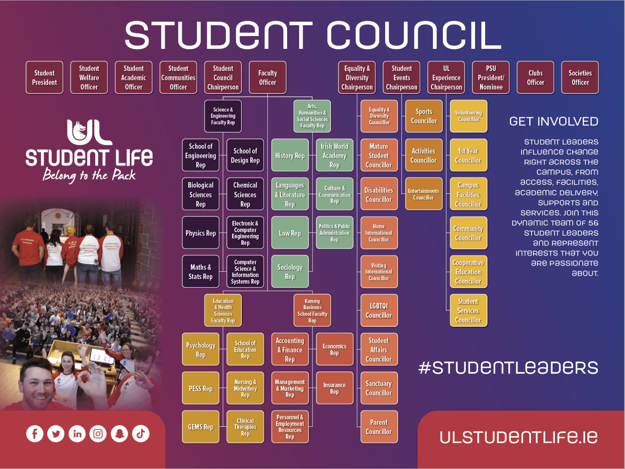

**Student Council Bye Law**

For additional information about your role on Student Council, please familiarise yourself with the Student Council Bye-Law here <https://www.ulstudentlife.ie/about/su-governance/> This is an important document as it explains the purpose and function of Student Council. You can also email [jasmine.ryan@ul.ie](mailto:jasmine.ryan@ul.ie) for further questions.

# Meet Your Student Officer Team

**Student President Vice President Academic Officer**

Ronan Cahill Ronan Mannix

Email: [studentpresident@ul.ie](mailto:studentpresident@ul.ie) Email: [studentacademic@ul.ie](mailto:studentacademic@ul.ie)

**Deputy President Welfare Officer Vice President Communities Officer**

Emily Rosenkranz Katie Martin

Email: [studentwelfare@ul.ie](mailto:studentwelfare@ul.ie) Email: [studentcommunities@ul.ie](mailto:studentcommunities@ul.ie)

Presidents Volunteer Award - PVA

As a member of Student Council you can apply for the Presidents Volunteer Award.

The award recognises the work of student volunteers within the University of Limerick and beyond. To apply for the Student Council Opportunity follow the steps below.

Step 1

Log onto <http://www.studentvolunteer.ie/sign-up> to create an account



Step 2

Select UL Student Council in ‘Opportunities’ search

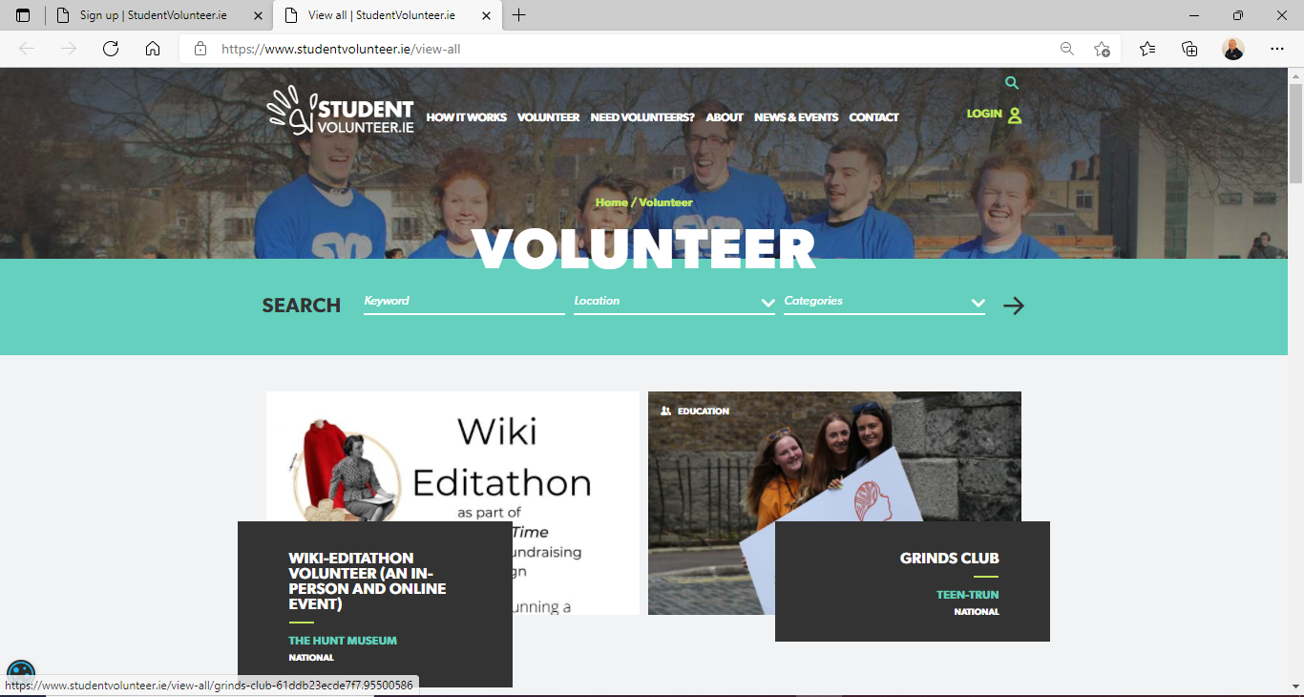

Step 3

* Log all your hours on studentvolunteer.ie.
* Make sure all hours have been approved by your volunteer supervisor.
* Complete reflective portfolio.
* **Students must achieve a minimum of 20 hours to apply for a PVA.**

**Types of Awards:**

**Gold -**minimum of 60 volunteer hours

**Silver -**minimum of 40 volunteer hours

**Bronze -**minimum of 20 volunteer hours

* Any questions - contact the PVA Team at [pva@ul.ie](mailto:pva@ul.ie)

# Meet the Leadership & Representation Team



**Gillian O’ Gorman  
Head of Student Leadership & Advocacy**

In my role as Head of Leadership & Advocacy, I oversee both the Leadership & Student Representation office, and the Student Information and Support Service. I work with a team of four staff, along with the four Student Officers, to ensure that the student voice is heard and fed back through university committees. This is done by providing our student reps with a comprehensive induction and leadership training through our Leaders for Life training program.

I am also responsible for ensuring that UL Student Life delivers a best-in-class support service through both student information and support co-ordinators. Trends in supports are examined monthly and feed into the overall delivery of service and the strategic direction of the organisation. As part of the Senior Management team, I am responsible for the development of organisational policies and good governance at all times.

Email: [gillian.ogorman@ul.ie](mailto:gillian.ogorman@ul.ie)



**Siobhán Willmott   
Student Representation Coordinator**

It is my job to recruit all student representatives and oversee the elections, as well as providing support and training opportunities to over 300 student reps each year. I love my job because I’m passionate about student voice, leadership, and representation. I would love to see a diverse and inclusive range of student reps so that all UL students feel their views are represented at a leadership level. If you share my passion and want to get involved, then nominate yourself to become one of the leaders of our pack. Don’t worry, we will provide Leaders for Life training to help you be a student rep.

Still uncertain of what’s involved or how to get involved? Contact me. We want to support you, so please get in touch. Send me an email or book an appointment using the links below.

Email [siobhan.wilmott@ul.ie](mailto:siobhan.wilmott@ul.ie)

**Jasmine Ryan**

**Leadership & Representation Administrator**

Jasmine is the Leadership & Representation Administrator and works alongside Gillian & Siobhán in the Student Leadership & Representation Office. Her primary role is to support the Leadership & Representation office in the recruitment, engagement, and training of all student representatives. She takes Student Council Minutes as well as circulating all documents before meetings. Jasmine is a member of the Class Rep Forum Planning team. She also processes the online Class Rep & Student Council nominations. Jasmine approves all of the Representation Opportunities for Student Reps through the Presidents Volunteer Award. She supports Siobhán in the recruitment of Student Reps & NStEP Training. She is the first point of call for all student representation queries that come to the Leadership & Representation Office.

Email [jasmine.ryan@ul.ie](mailto:jasmine.ryan@ul.ie)

**Appendix One**

**Sample Introduction Email (Course Leader)**

Hello ____ ,

My name is ___ and I am the Department Rep for (Insert Department Name).

I wanted to reach out to say a virtual hello.

My role as an elected Department Rep is to gather departmental feedback from students and use this to improve the student experience within the department.

I also sit on the Student Life Council where I raise student concerns and discuss solutions with other students. I have a good working relationship with the Academic Officer, Kieran, and keep him updated on any feedback I gather.

I would love to have a meeting with you in which I could bring the student voice and feedback any updates to class reps. Let me know if this is something you think could work and where I could contribute.

I look forward to working with you throughout the year.

Many thanks,

**Appendix Two**

**Sample Introduction Email (Class Reps)**

Hello ____ ,

My name is ___ and I am the Department Rep for (Insert Department Name).

I wanted to reach out to say a virtual hello and introduce myself.

My role as an elected Department Rep is to gather departmental feedback from students and use this to improve the student experience within the department.

I also sit on the Student Life Council where I raise student concerns and discuss solutions with other students. I have a good working relationship with the Academic Officer, Kieran, and keep him updated on any feedback I gather.

I will be attending departmental meetings in which I could bring the student voice and feedback any updates back to you. Let me know if this is something you think I should bring to the meetings.

I look forward to working with you throughout the year.

Many thanks,

___________

**Appendix Three: Class Representative Modular Feedback Procedure**

Class Representative:

It is the responsibility of the Class Representative to begin the process of formally submitting Modular Feedback. Modular Feedback can be any of the following issues

* Inaccessible Lecture/ Reading List Materials
* Issues regarding **in-semester** examinations, quizzes, assessments (Wk 1-13)
* Issues regarding unfair treatment of individual(s) (Refer to SISC)
* Issues regarding inappropriate/ out-of-date/ discriminatory/ biased modular content without good reason and/or prior explanation for its usage (e.g. of good reason: used in a context to form an argumentative, historically accurate, multi-dimensional context that is not targeted at any individual studying the module)
* Issues regarding remote accessibility
* Issues regarding appropriate supports for students registered with the Disability/ Access Office(s) (In Conjunction with Disability Rep at ULSL Student Council).
* Module Registration (In conjunction with Academic Registry)
* Personal Issues (Refer to SISC/ Support Services)
* Any other issue that **both** the module leader and the Class Representative(s) agree should be discussed to achieve better attendance, participation, or modular outcomes for the students.

The Class Representative should collect quantifiable feedback and be able to present it to the Module Leader in a meeting. This should be **statistically valid** (i.e. at least 25 responses; AND/OR 50% +1 of the module participants; AND/OR a representative sample of the impacted individuals) and **presented in** **a report, of which a template is available from the LRO**. This report will contain the following information

* Class/ Module Size
* Size of Sample
* Method of Data Collection
* Method used to ensure Statistical Validity
* Summary of Problem Raised (max 250 words)
* Summary of Quantifiable Data proving this is a class issue (Attach survey + results)
* Summary of Qualitative Data to supplement the Quantifiable Data (optional)
* Action Points to resolve the issue (fill out by the students)
* Recommended Course of Action (filled out by Module Leader)

The Class Representatives should inform the Department Representative of the need to create a meeting and share the report and all supplementary/ supporting materials to help them understand the full issue, so that they can create a Summary of the issue, which they will read back to you and the Module Leader at the beginning of the meeting to ensure it is wholly accurate.

As a guide, the issue can then be escalated if any of the below occur

* Module Leader does not respond within 5 working days
* Class Representative do not agree to the Recommended Course of Action
* If the Recommended Course of Action proposes an escalation.

The issue can be escalated to the following individuals

1. Department Representative for an academic query
2. Faculty Representative for an issue that correlates within 3+ modules in the same faculty.
3. SISC for any personal related issues including bullying, harassment, stress.
4. Leadership and Representation Office if the Class Representative(s) are not responding/ giving an incomplete report.
5. Full-Time Student Officer if one of the previous 4 avenues are deemed inconclusive or if recommended by any of the other streams.