Class Representative
Congratulations on becoming a class Rep. As an elected Class Rep you play an essential role as the main link between your class and faculty.
The position of Class Representative is a vital role in the representation structure at the University of Limerick
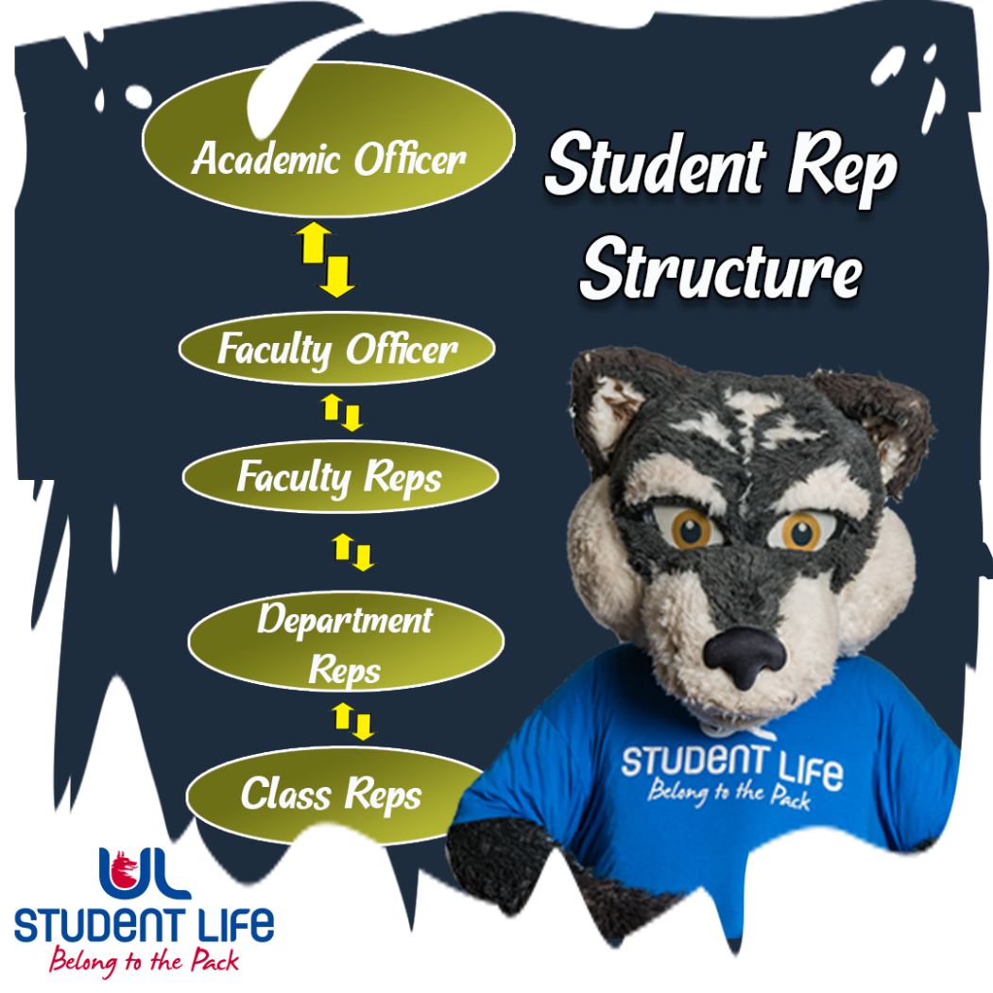

Your Role & Responsibilities
Class Representatives act as the link between the Class and the Module Leaders for all Representation Issues. Their responsibilities include creating their own record of the conversation and resolutions/ differences that they note. The Class Representative must include all fellow Class Representatives involved in any correspondence and request a meeting with everyone present. If you are unsure about all the Class Representatives involved, please email jasmine.ryan@ul.ie for the updated list.
You have a hugely important role in Student Leadership
- You should introduce yourself to your Module Leader as soon as you are elected and request a virtual meeting. (See Appendix One for sample email to Module Leader).
- Seek additional support from Faculty Rep / Faculty Officer & Academic Officer.
- It is not your responsibility to support students with personal issues. Encourage students to book a call with our Student Information and Support Coordinators.
  - Book in with Nicole or Shane. You can learn more about their services here.
- You must attend NStEP training as it will give you important skills to help you fulfil your role. Log onto the link here for more information https://studentengagement.ie/student-training/

Summary of role
Class Representatives are elected by their peers to represent the student body at Departmental Student Staff Committee meetings. In fulfilling their role, Class Reps actively seek the views of their peers on academic issues relating to their programme and collate the feedback for presentation at Class Rep Forums and Staff / Student Committee meetings. They are expected to proactively pursue improvements to their course or research group and seek to maintain and promote examples of best practice. As a Class Representative, you are responsible for collecting and communicating your fellow classmates’ views, opinions, concerns and needs to your School and other student representative groups.

UL Student Life aims to have at least one elected Class Representatives per cohort of each degree programme. For degree programmes with more than 50 students per cohort, the Students’ Union aims to have at least two elected course representatives and so on as the class numbers increase.

